**AWS IoT Predictive Maintenance**

Tools used

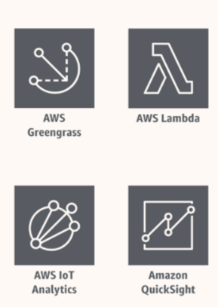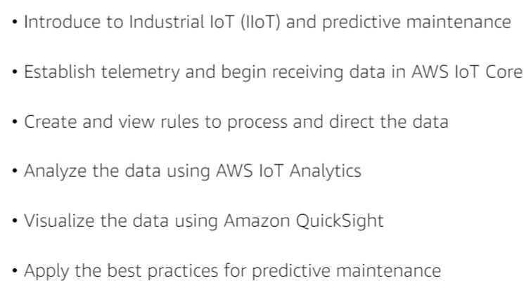

**Industrial Internet of Things**

As, the name suggests IoT that is implemented on an industrial level. It consists of 3 use cases(mentioned below)

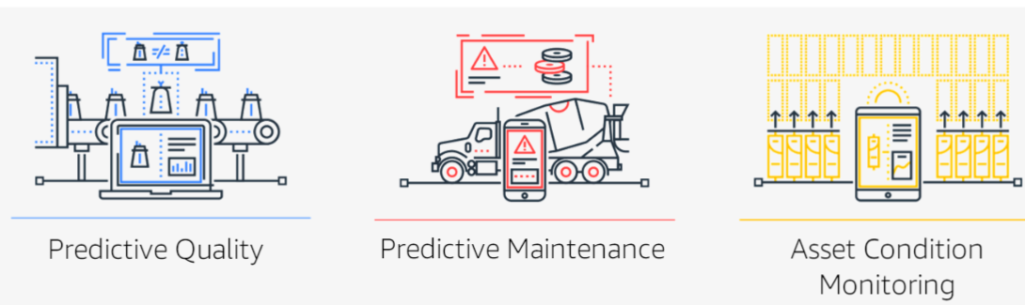

**Predictive Maintenance:**

It is the process of maintaining the device or ‘the thing’ that is deployed in the environment let it be industrial or individual. Predictive maintenance helps in identifying the issue in an earlier stage and fix it before the failure happens during operations.

Architecture:

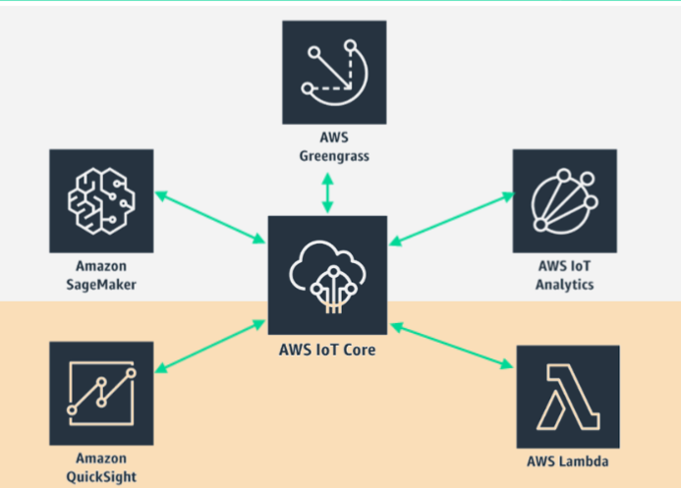

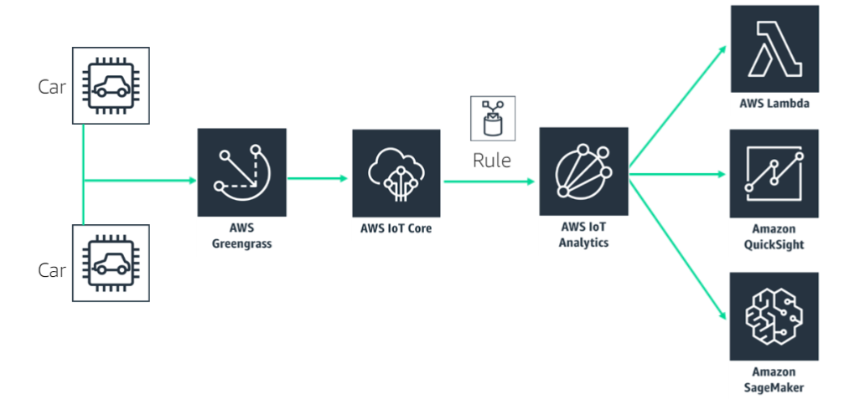

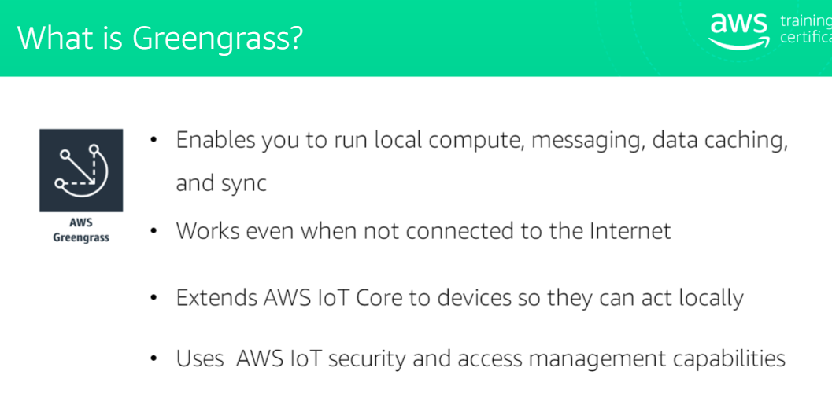

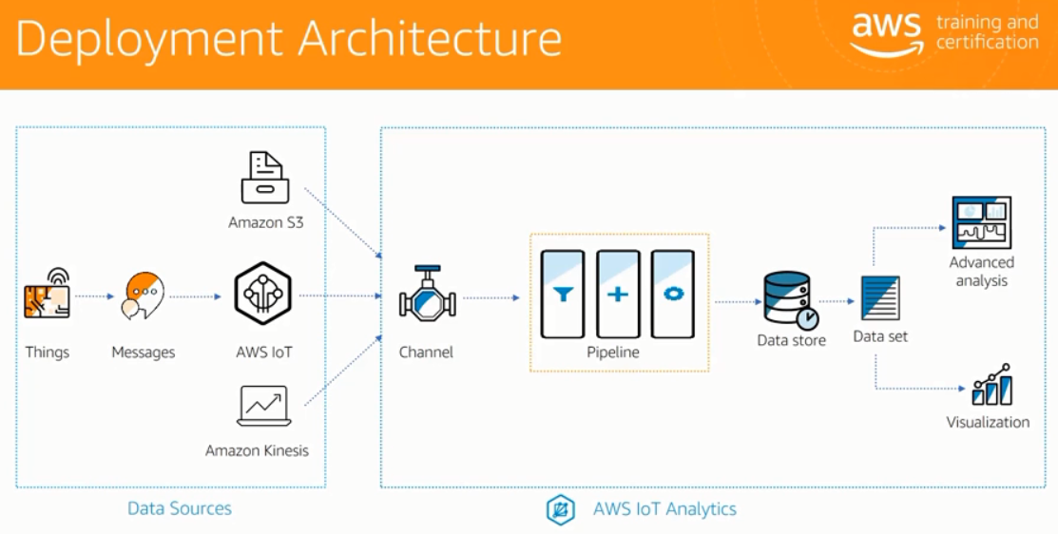

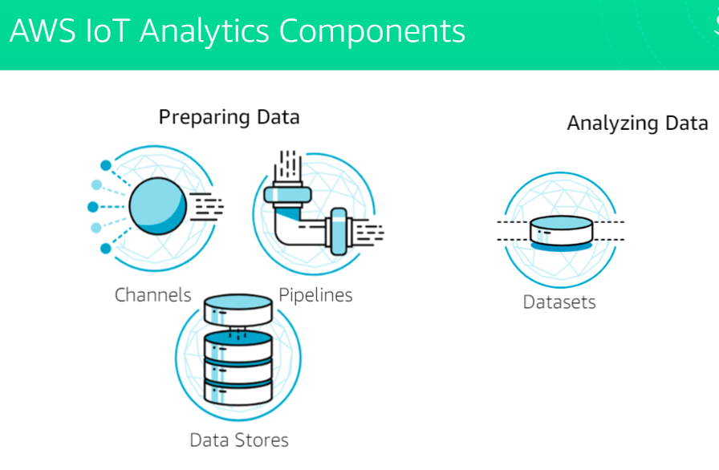

**Predictive Maintenance Best Practices:**

